**Shri Ram Murti Smarak College of**

**Engineering & Technology, Bareilly (U.P.)**



Synopsis on “**Face detection for Attendance”**

**Submitted to:- Submitted by:-**

Mr. Manoj Kumar Amisha Saxena

(Assistant Professor) (1801413001-IT 18)

**Guided by: -** Mansi Chandra

Mr. Lalit Kumar Narayan (1801413029-IT 18)

(Assistant professor) Tamanna Jawrani

(1801413056-IT 18)

**Acknowledgement**

We would like to express our sincere gratitude to our Project Incharge-Mr Manoj Kumar and our Project Guide-Mr Lalit Kumar Narayan for providing their invaluable guidance, comments and suggestions throughout our project.

We would specially thank Mr Lalit Kumar Narayan for constantly helping us providing suggestions to improve our project.

**Table of Content**

|  |  |  |
| --- | --- | --- |
| S.R No | Page Title | Page No |
| 1 | Introduction | 4-5 |
| 2 | Motivation | 5-6 |
| 3 | Problem Formulation | 6-7 |
| 4 | Objective | 7-8 |
| 5 | Literature Survey | 8-9 |
| 6 | Tools and Technology | 9-10 |
| 7 | Methodology | 10-14 |
| 8 | Features | 14-15 |
| 9 | Conclusion | 15-16 |
| 10 | Future Enhancement | 16-17 |
| 11 | References | 17 |

**Introduction**

In the 21st century, everything around us has become depends upon technology to make our life much easier. Daily tasks are continuously becoming computerized. Nowadays more people prefer to do their work electronically. To the best of our knowledge, the process of recording student’s attendance at the university is still manual. Lecturers go through manual attendance sheets and signed papers to record attendance. This is slow, inefficient and time consuming. The main objective of this project is to offer system that simplify and automate the process of recording and tracking student’s attendance through face detection technology. It is biometric technology to identify or verify a person from a digital image or surveillance video. Face detection is widely used nowadays in different areas such as universities, banks, airports, and offices. We will use pre-processing techniques to detect, recognize and verify the captured faces like Eigenfaces method. We aim to provide a system that will make the attendance process faster and more precisely. The core problem is identified along with solutions and project path. Furthermore, detailed system analysis and design, user interface, methods and the estimated results are presented through our documentation.

**Motivation**

Face recognition has recently received a blooming attention and interest from the scientific community as well as from the general public. The interest from the general public is mostly due to the recent events of terror around the world, which has increased the demand for useful security systems. Facial recognition applications are far from limited to security systems.

We are using this technology for automatic attendance system which can help the lecturers to maintain the attendance records of students without wasting the paper and time.

**Problem Formulation**

Taking and tracking student’s attendance manually, losing attendance sheets, wasted time and high error scales are problems facing the lecturers use the existing attendance system. It is a hard process, take time and cause a lot of paper-based work. As a result, in order to solve these problems and avoid errors, we can use the technology like face detection to computerize this process by providing a system that record and manage student’s attendance automatically without needing to lecturer’s interference.

**Objectives**

The main goal is to help the lecturers, improve and organize the process of track and manage student attendance and absenteeism.

Some main objectives are: -

* Provides a valuable attendance service for both teachers and students.
* Reduce manual process errors by provide automated and a reliable attendance system uses face recognition technology.
* Produce monthly reports for lecturers.
* Flexibility, Lectures capability of editing attendance records.
* Calculate absenteeism percentage and send reminder messages to students.

**Literature Survey**

Face detection is a computer technology that determines the location and size of human face in arbitrary (digital) image. The facial features are detected and any other objects like trees, buildings and bodies etc are ignored from the digital image. It can be regarded as a specific case of object-class detection, where the task is finding the location and sizes of all objects in an image that belong to a given class. Face detection, can be regarded as a more general case of face localization. In face localization, the task is to find the locations and sizes of a known number of faces (usually one). Basically, there are two types of approaches to detect facial part in the given image i.e. feature base and image base approach. Feature base approach tries to extract features of the image and match it against the knowledge of the face features. While image base approach tries to get best match between training and testing images.

**Tools and Technology**

System Requirements: -

1. System Type - 64 Bit Operating System
2. RAM - 4 GB
3. Processor - INTEL CORE i3 (2.30 GHz)

Technology Used: -

1. Language used - Python 3.8.3 (Anaconda)
2. Libraries used - Open-CV

Face-recognition

dib

NumPy

Editor: -

1. VS Code

**Methodology**

1. **Basic Face Matching**

* First, we get the location of where exactly the face is in the image using face_location() method (which gets the outline of the face) on the RGB image. Then face encodings(markings of eyes, nose, mouth, jaws which remain the same for different images of the same person) are taken using face_encodings() function which returns a list containing 128 measurements. Both these two steps are followed for the original and test image. Then a comparison between these two returned lists is done by the function compare_faces() which returns a list of boolean values(True or False). The face distance function gets the value of that by how much the two images differ. The lower the distance the better the matching and vice versa.

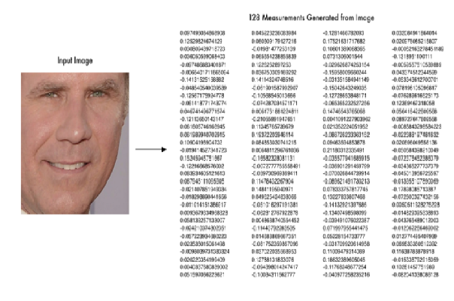

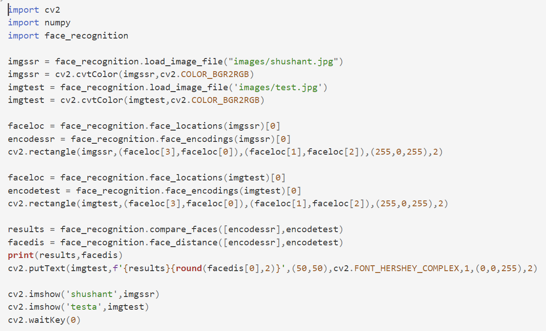

1. **Building Face Attendance System**

* Now we are ready to build a Realtime face attendance system wherein webcam captured frames will be matched against the existing database images and if the match is found then it will store it in a CSV file called ‘Attendance.csv’ along with name and Datetime of capture. Only once the file will store the matched image’s details, if the same image is received again then it’ll not update.
* Path setting to the directory containing the image database. Read each image and the images array. Append the filenames into a list called Names and remove the extension.

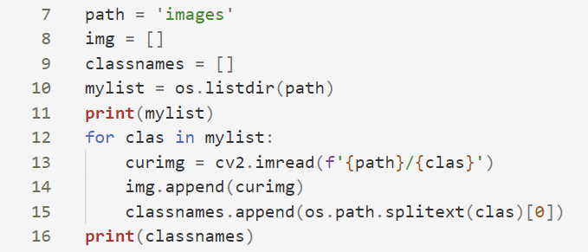

* Finding face encodings of images in the database and keeping them in a list to use later with incoming frames.

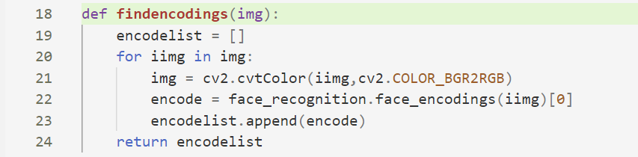

1. **Capturing video frames**



The same process is followed by the first detection face location then getting the face encoding values.

1. **Now the incoming images are tested against the previously-stored encodings.Then the face distance is also computed. Lastly, we call the Attendance function along with the person name who is identified.**

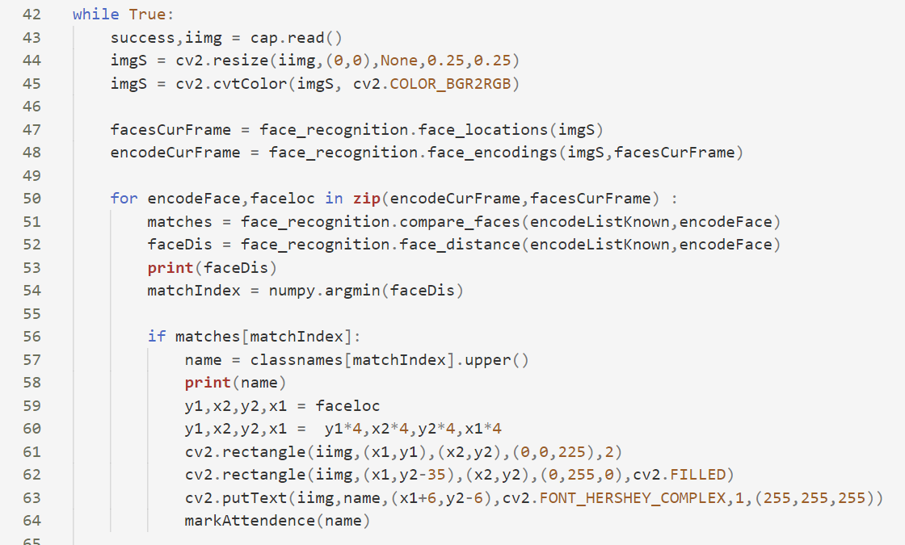

1. **Reading from attendance file, Storing data (Name and Date Time**

**of entry)**

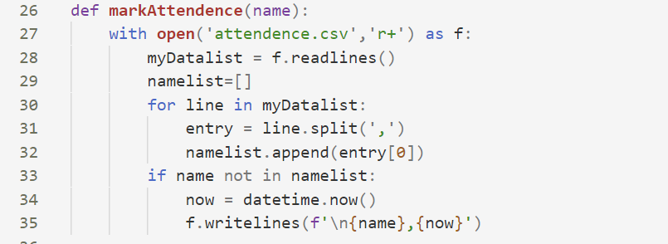

**Features**

* The system stores the faces that are detected and automatically marks attendance.
* Provide authorized access.
* Ease of use.
* Multiple face detection.
* Provide methods to maximize the number of extracted faces from an image.

**Conclusion**

Face detection library being a high-level deep learning library helps in identifying faces accurately. We have used this to build a face attendance system which can be helpful in offices, schools or any other place reducing manual labour and automatically updating the attendance records in day-to-day life. This also notes down the time of arrival thus can acquire information about people coming in late after a specified time.

**Future Enhancement**

* We can make a web application by using FLASK and React JS so that students can interact with this technology in more efficient manner.
* We can add more features like attendance seeing system for student.
* We can also build the employee attendance management system.

**References**

* [www.google.com](http://www.google.com)
* [www.wikipedia.com](http://www.wikipedia.com)
* [www.w3schools.com](http://www.w3schools.com)
* [www.geeksforgeeks.org](http://www.geeksforgeeks.org)
* [www.tutorialspoint.com](http://www.tutorialspoint.com)
* docs.python.org/3/tutorial